**Project app Green&Fit Food**



**Introduction :**

The project aims to create an app for the restaurant green fit Food in Geneva city. This restaurant is an healthy & poke bowl restaurant who preparing fesh salad and poke bowl, fresh juice and smoothies sweet treat and desert. We want an easy-to-use, intuitive and practical application for the customer to increase our sales and to streamline services.

Here is attached a structure for the future android and ios app the color codes and design are examples however the operation will have to respect the outline.

You will have to be creative I want a design inspired by large delivery apps (uber type, deliveroo ...) and I want creativity.Thanks a lot

**1st) Design of App for Customer**

1.Opening app



2)Main page:

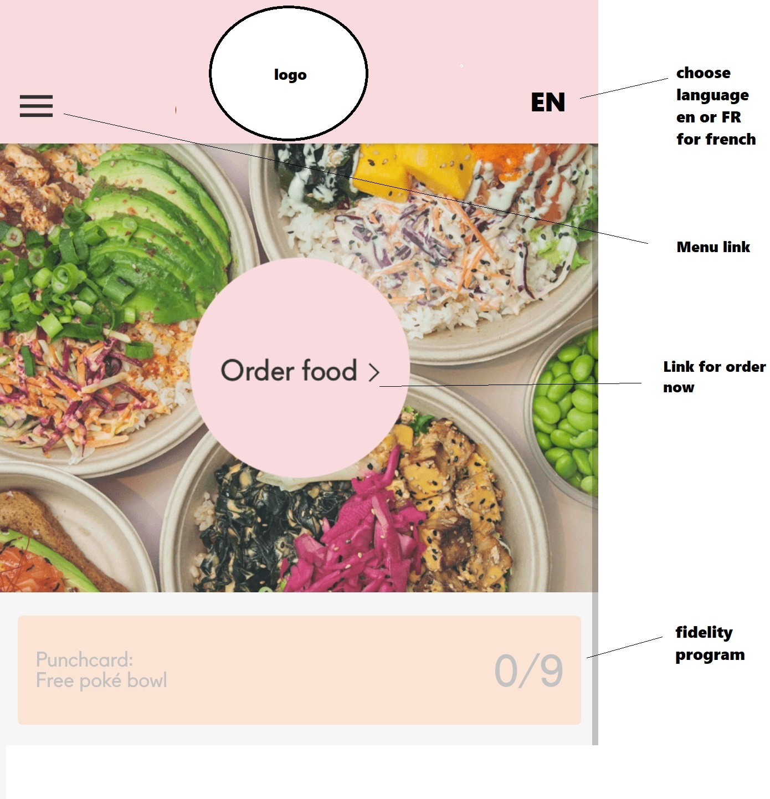

2.1click on /Order Food page 1

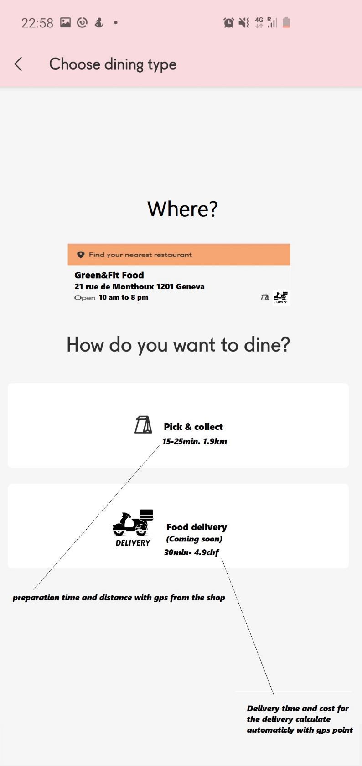

2.2 Order now page 2

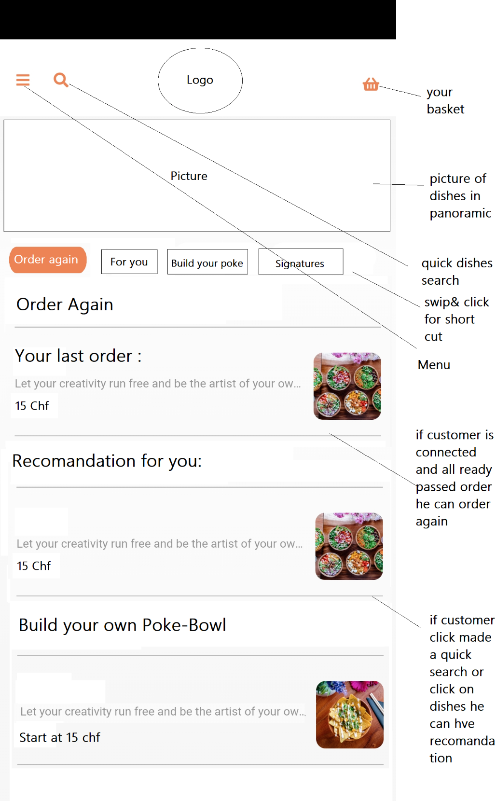

The order of the flat and the shortcut must be like this:

1:Order again ,2: For you ,3: Build your own poke bowl, 4: Our Poke signature ,

6 : Salads , 7 : wraps, 8 : Mochi ice crean ,9 : Desert ; 10 : Drinks

2.2.a) Menu

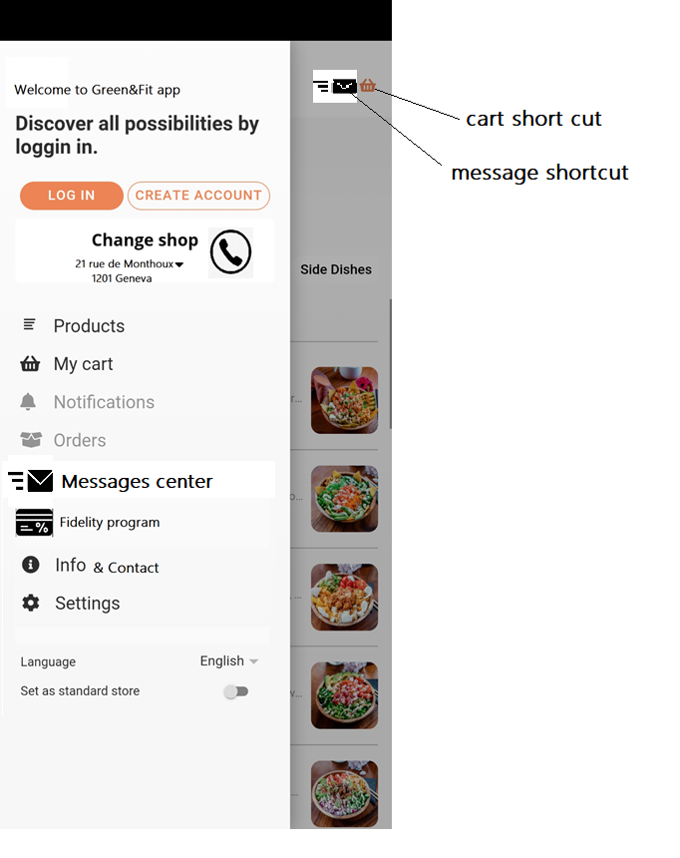

2.2.b) quick dishes search

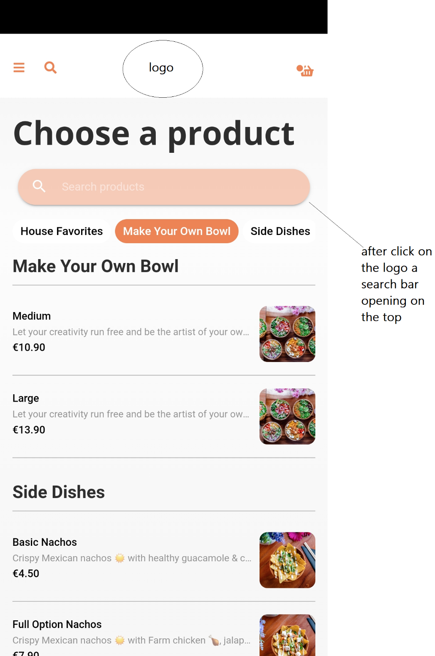

2.2.c)Choose a product

*after click on product :*

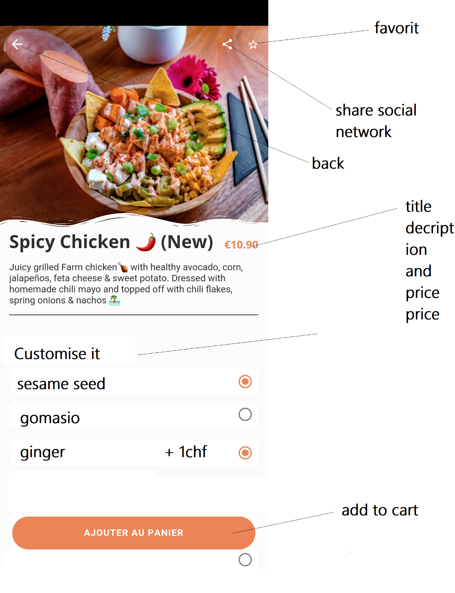

This an expample for our siganture poke bowl,

It gonna be different if customer Choose build your own poke bowl customer have to choose :

1)Protein : chicken,salmon,tuna,tofu,shrimps,beef and Extra

2 Dress it :choose the sauce

3) Base it: choose rice

3) Colour it with vegetables

4)Finish it :choose toppings

5)Choose :knife Fork or chopstick

Have look on the list :

https://greenfitfood.hiboutik.com/food/

2.2.d) Basket

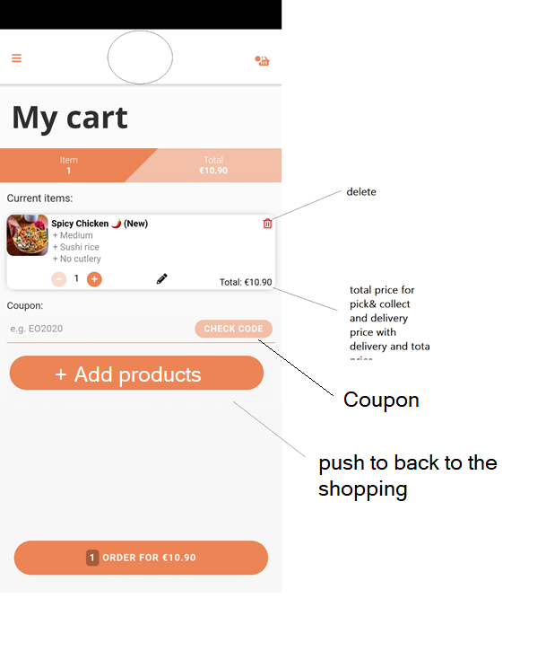

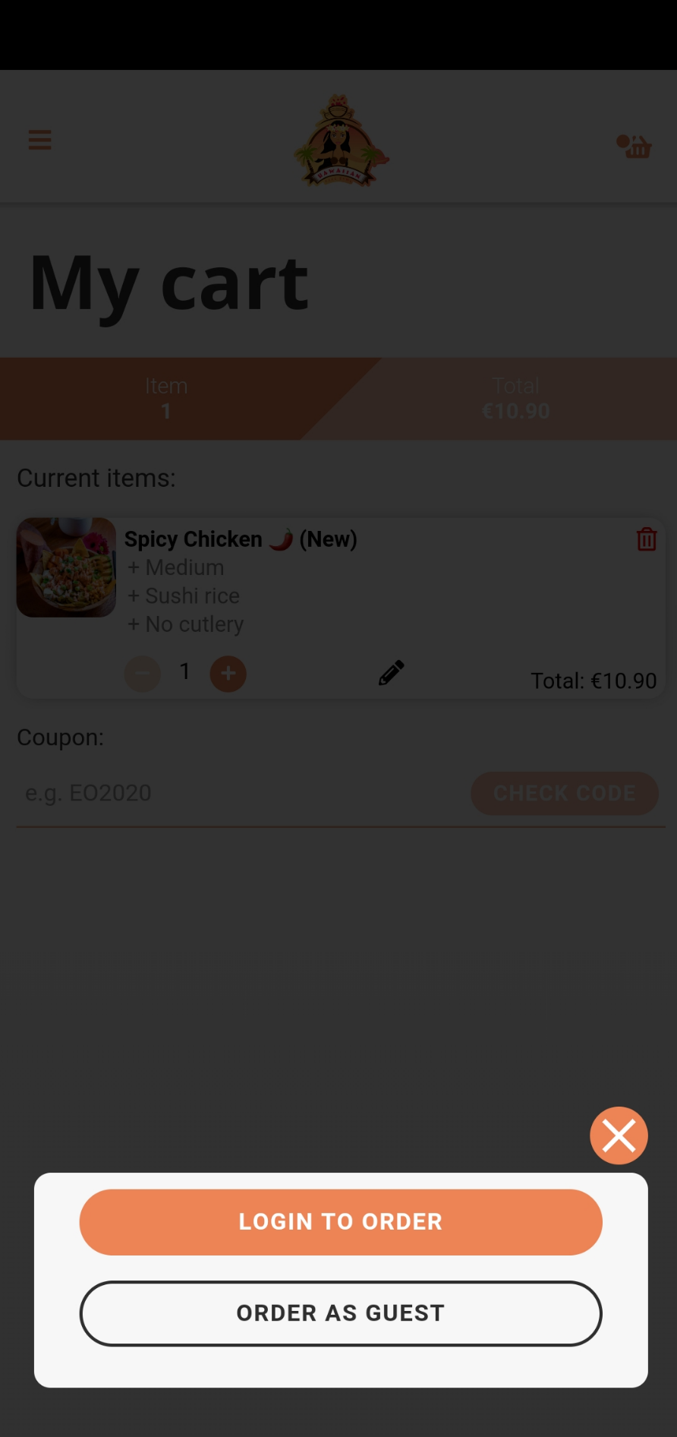

*This very important my customer can login or order as guest ,

*The customer order as guest have to pay with stripe (Credit card) and customer who is login can pay buy cash and strype paiement*

Login page :

The customer can sign in with account or facebook google or instagram.

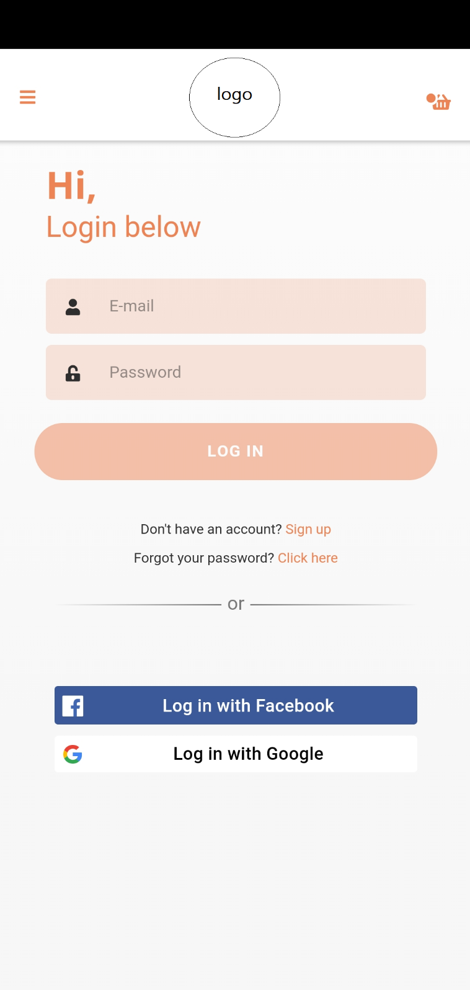

Continue as guest :

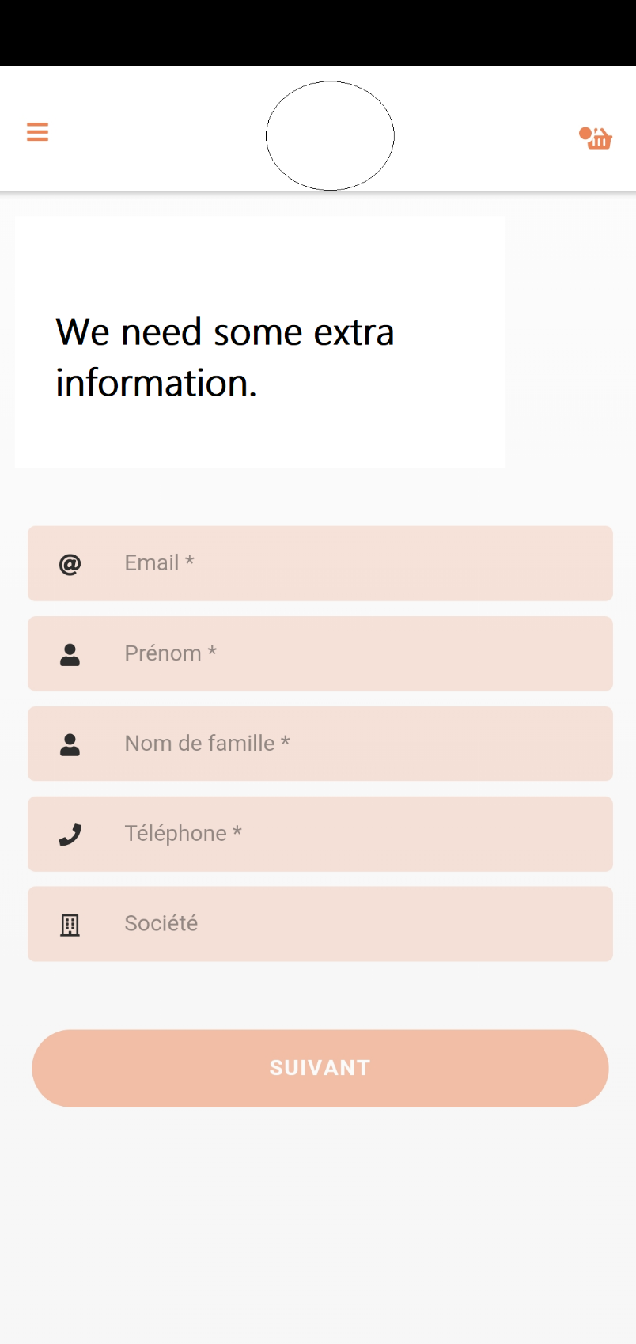

After order and login as guest or login like a user we have this last step :

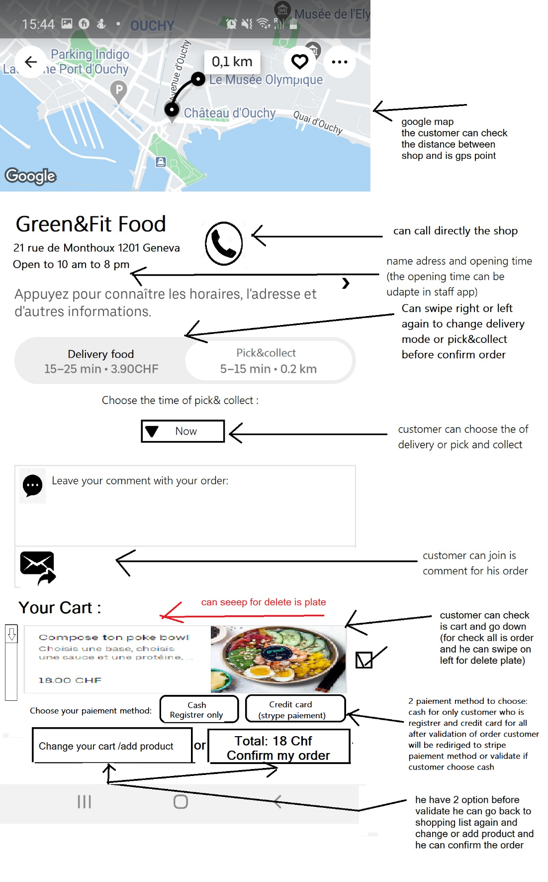

Customer have to validate again before confirm :

We resume the total price and the delivery mode with the time

Push yes and confirm or no and back to the last step:

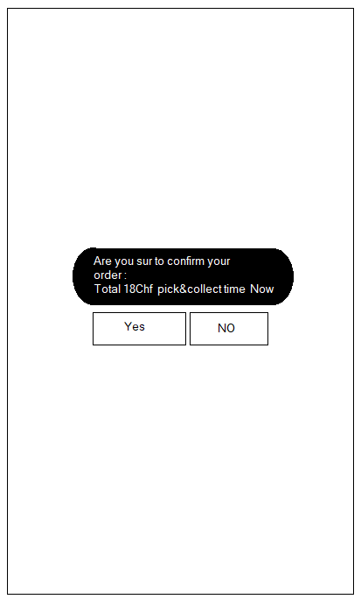

The Main menu:

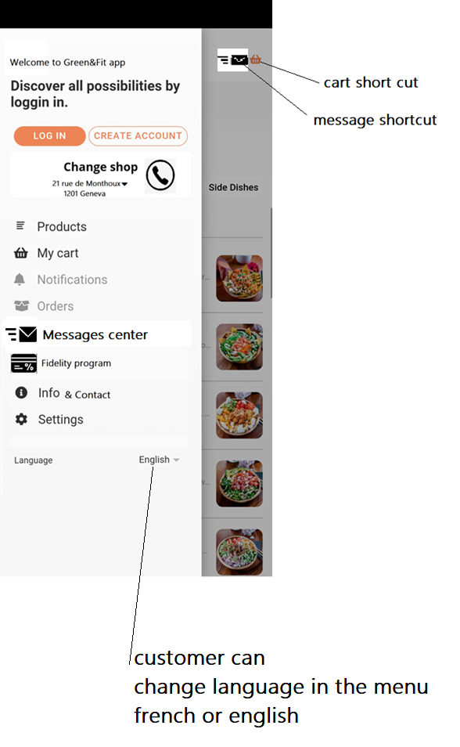

Notifications :

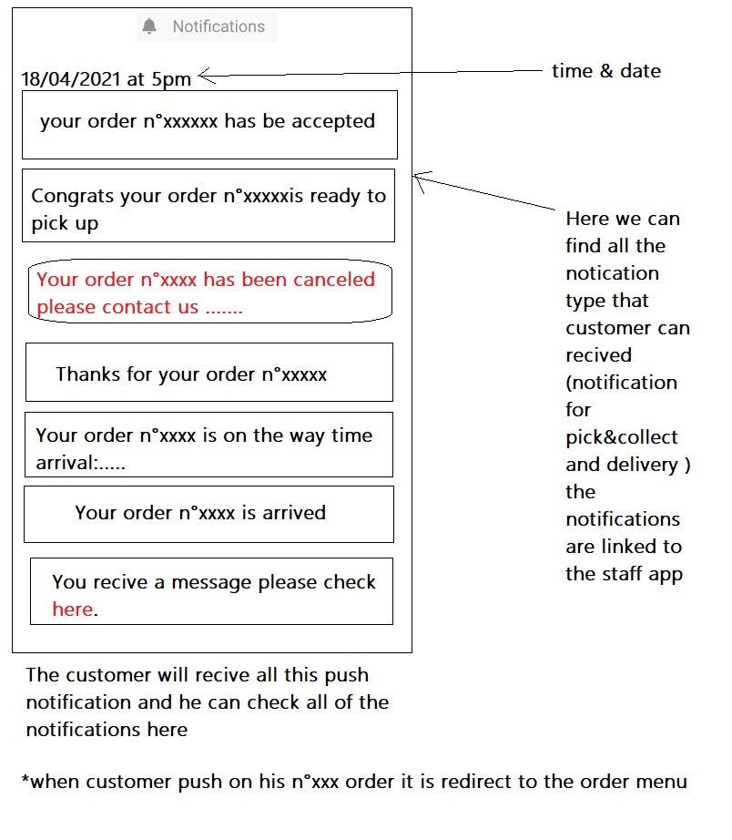

Order menu:

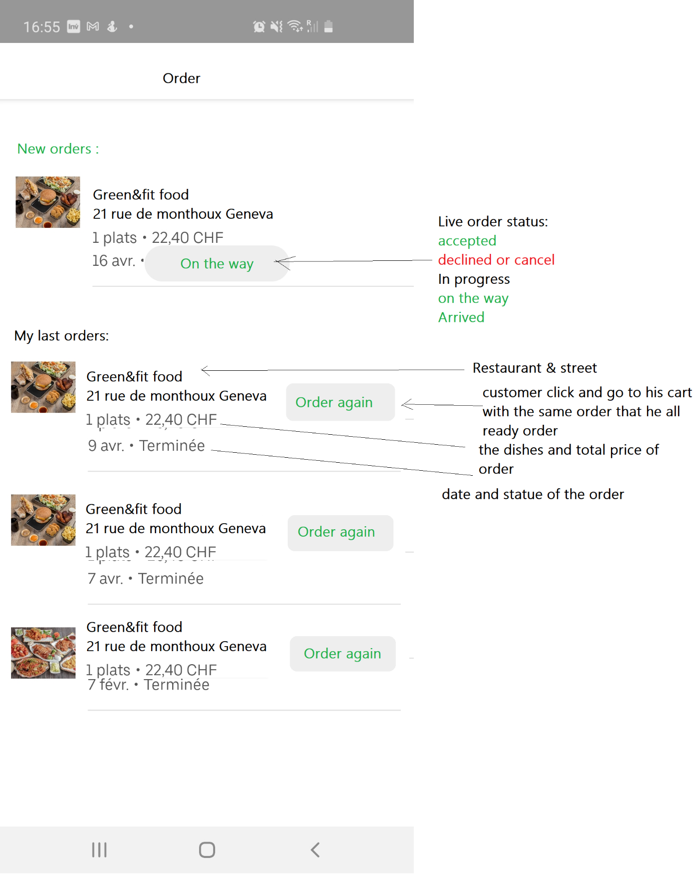

Message:

Customer can text us and we can answear to customer with the staff app we can put chat offline or line in th staff app

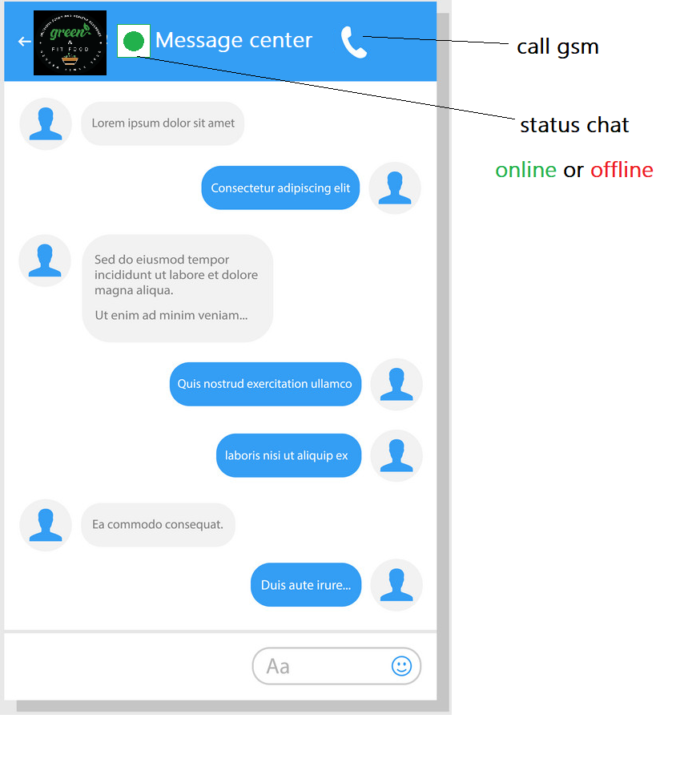

Fidelity programs & Promotions:

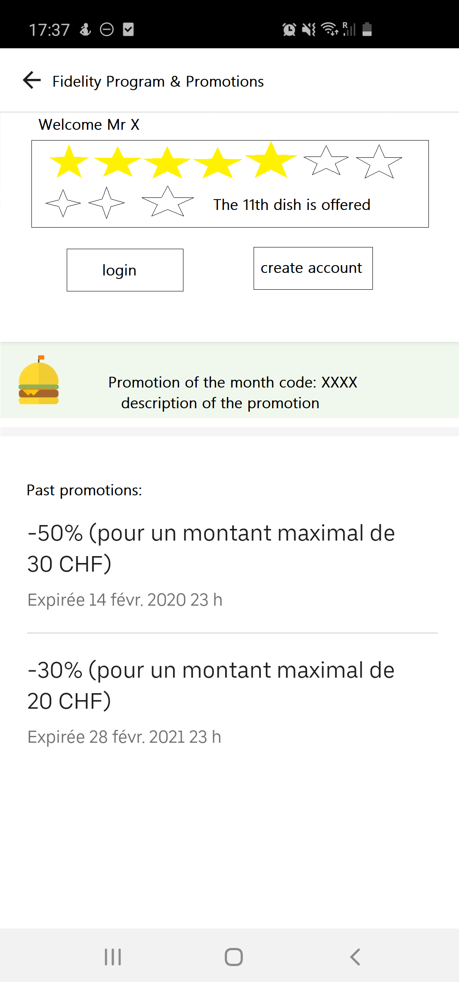

Menu info & contact:

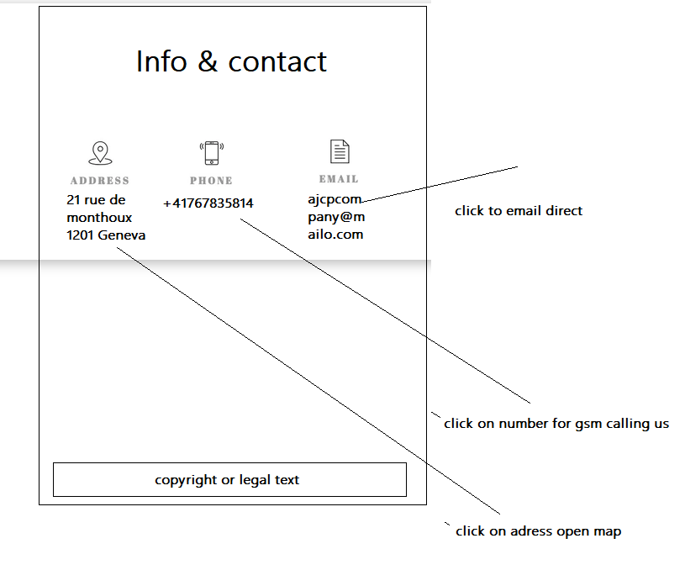

Settings& profil:

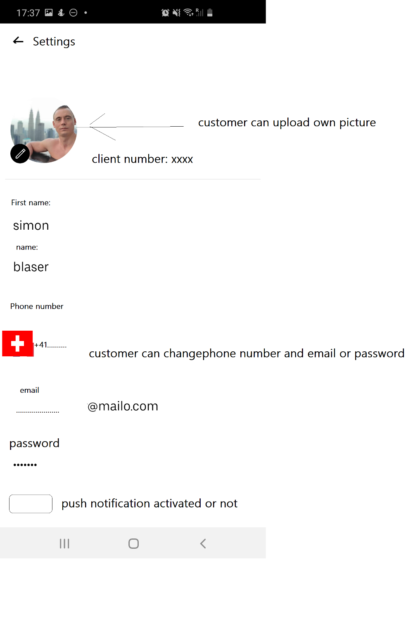

Language:

Customer can swipe to change the app in french or english

To make your work easier I found an interesting application structure I also used this app to present the project to you, I modified a few things for it is therefore not similar but the configuration can be the even the design on the other hand must be different

Check the link of this app:

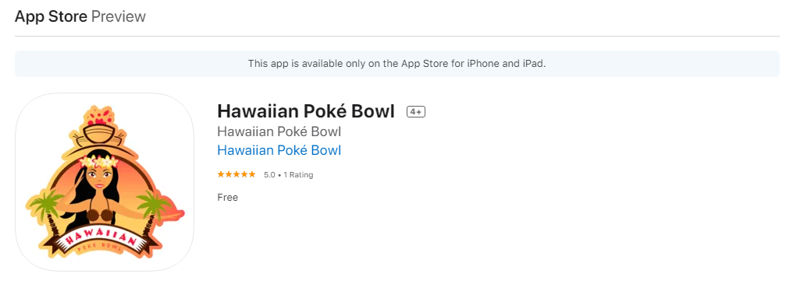

<https://apps.apple.com/be/app/hawaiian-pok%C3%A9-bowl/id1558683566>